Networks / PCA / connectedness: NZDUSD and USDJPY
Method 28 / pair slice of eight-major system / Alpari D1 full available history

Study setup
Logical pair: NZDUSD , USDJPY
Broker symbols: NZDUSD_i , USDJPY_i
Snapshot: 2026-11-03_majors_alpari_D1
Timeframe: D1
Matched return window: 1999-01-05 to 2026-11-02 (UTC bar dates)
Matched return count n: 7185
System panel n: 7127
Dropped unfinished last bar dated 2026-11-03 UTC after a tick-volume check against the prior complete day.
VAR lag (BIC): 1; GFEVD horizon H=10
System TCI: 54.0425
Complete matched rows (Excel): NZDUSD-USDJPY_Network_D1.xlsx

Method carried forward
Three system-level tools on the eight-major daily log-return panel. (1) Network distance d_ij = sqrt(2*(1-rho_ij)) from Pearson correlation. (2) PCA eigenvalues of the correlation matrix R (R v = lambda v). (3) Diebold-Yilmaz total connectedness index (TCI) from a VAR with generalised forecast-error variance decomposition (GFEVD), horizon H=10; lag order chosen by BIC with maxlags=10. TCI = 100 * sum_{i!=j} theta_tilde_ij / N after row-normalising GFEVD shares. Pair reports show d_ij, rho_ij, and the directed pair spillover shares from the system theta_tilde matrix. Edges and TCI are not trading signals.

Pair results
Pearson rho: -0.133871
Network distance d_ij: 1.505902
theta_tilde[NZDUSD->USDJPY] (row NZDUSD, col USDJPY): 0.006441
theta_tilde[USDJPY->NZDUSD] (row USDJPY, col NZDUSD): 0.014297
PCA lambda_1: 3.817794
PCA variance share PC1: 0.477224

Conclusion
For NZDUSD-USDJPY: d_ij=1.5059 from rho=-0.1339. Pair spillover shares 0.0064 / 0.0143. System TCI=54.04. Not a trading signal.

Pair charts
Daily closes

Daily log returns
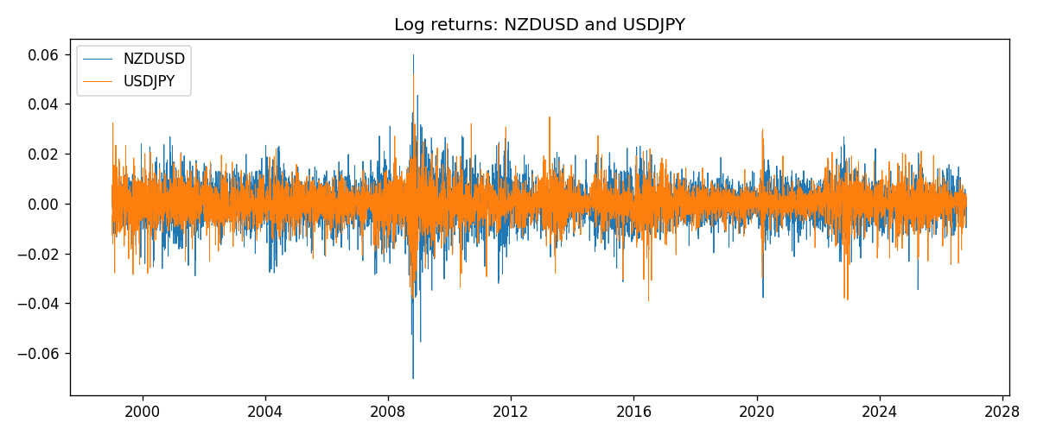

System charts (shared)
Correlation matrix

Distance matrix

PCA eigenvalues

GFEVD theta_tilde


Data report
First 15 matched rows
time | NZDUSD_log_return | USDJPY_log_return
1999-01-05 | -0.0018597736 | -0.00017868311
1999-01-06 | 0.0020455609 | 0.0075660159
1999-01-07 | 0.0062963171 | -0.012851583
1999-01-08 | -0.00055396548 | -0.0047719894
1999-01-11 | 0.010290425 | -0.016195423
1999-01-12 | -0.0053157489 | 0.032310364
1999-01-13 | -0.0099742238 | 0.0081373171
1999-01-14 | -0.00018564931 | 0
1999-01-15 | -0.00074294208 | 0.0055343401
1999-01-18 | -0.0018597736 | 8.7600193e-05
1999-01-19 | 0.0018597736 | -0.0056219403
1999-01-20 | 0.0040793678 | -0.0053879917
1999-01-21 | 0.0040627941 | 0.0084664056
1999-01-22 | -0.012051689 | 0.0060412564
1999-01-25 | -0.0035504102 | -0.0073594164
Last 15 matched rows
time | NZDUSD_log_return | USDJPY_log_return
2026-10-13 | 0.0047326165 | -0.0018932826
2026-10-14 | -0.0037306483 | 7.5800166e-05
2026-10-15 | 0.0047634855 | -0.0018524319
2026-10-16 | 0.0057501001 | -0.00037976126
2026-10-19 | 0.0018917133 | 0.0034946841
2026-10-20 | 0.0037199341 | -0.0022546642
2026-10-21 | 0.0030923331 | -0.00032883504
2026-10-22 | -0.0033035227 | -0.0085942669
2026-10-23 | 0.0030929853 | 0.00035080446
2026-10-26 | -0.0028993932 | 0.0041238746
2026-10-27 | -0.00026399852 | 0.0027651658
2026-10-28 | -0.0097283914 | -0.00095679538
2026-10-29 | 0.00062190714 | -0.00038043789
2026-10-30 | 0.00019537668 | -0.0010596481
2026-11-02 | -0.0025962955 | 0.0026438521

